BICYCLE FRAME ANALYSYS

# INTRODUCTION

My aim was to analyse a bicycle frame. I used Ansys 14 as the software to analyse the frame that I build in Solidworks 2012. For manual validation programming help was taken. There we used the help of Matlab 2011b. The results both the cases were a near match. Only displacement of each node was verified using the programme. The load applied was in accordance to normal weight of a person which is approximately around 700 N. The reaction forces were observed near the ends where tyres are fixed in the bicycle.

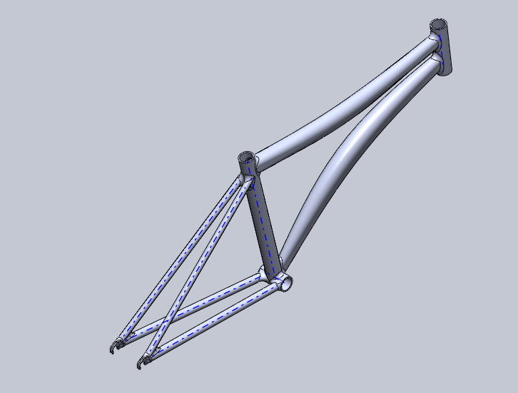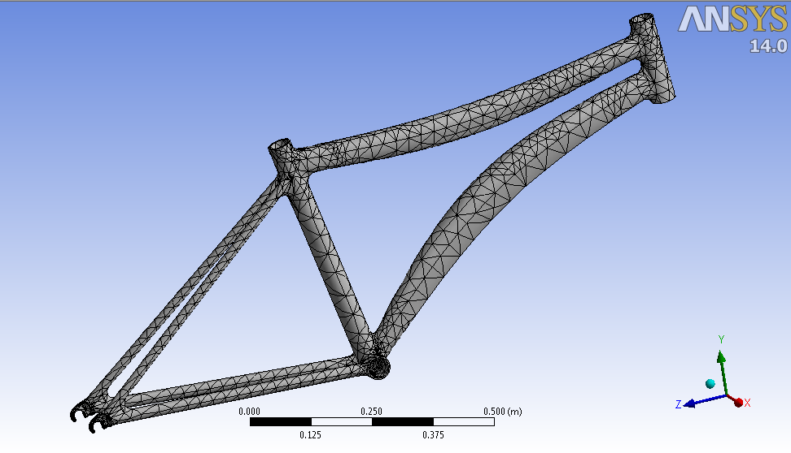

*Bicycle Frame Solid model Meshed model (Tetrahedral elements)*

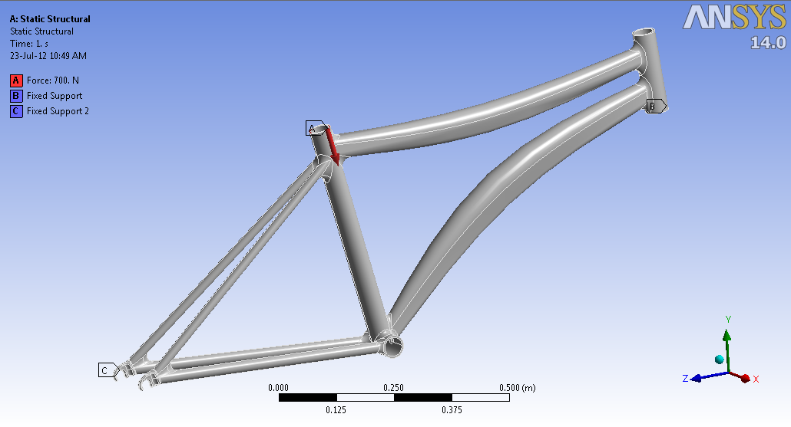

*Loads and Constraints applied during Pre-processing*

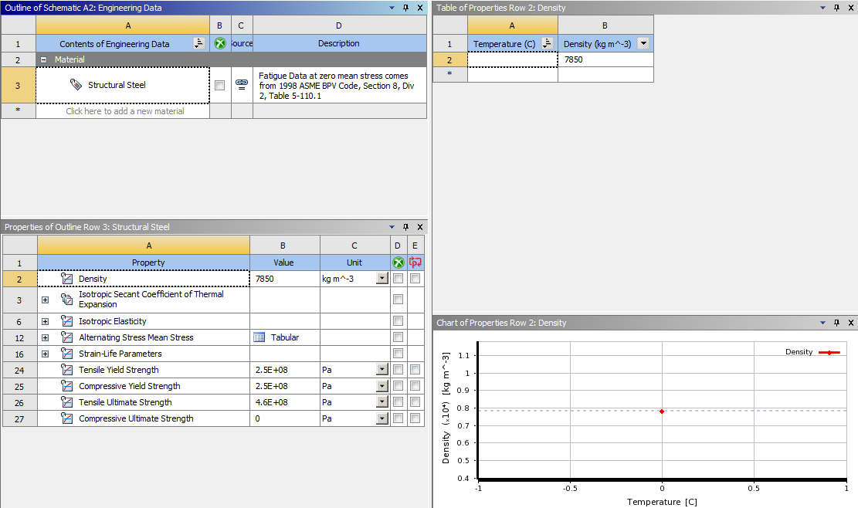

*Engineering Data Provided*

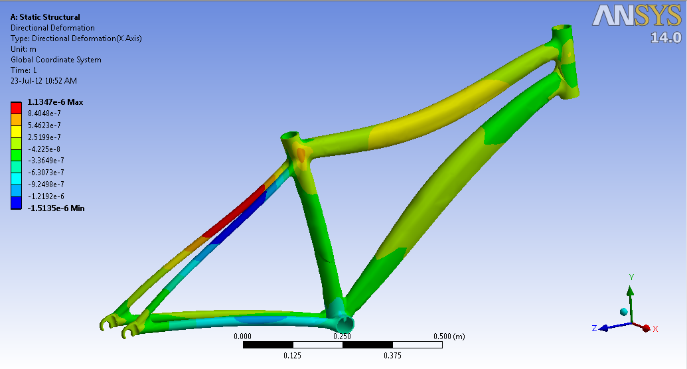

*Directional Deformation X-Axis*

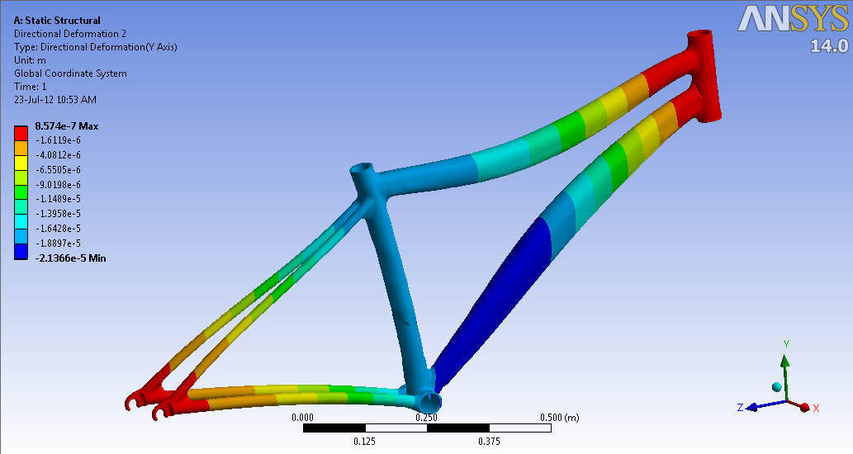

*Directional Deformation Y-Axis*

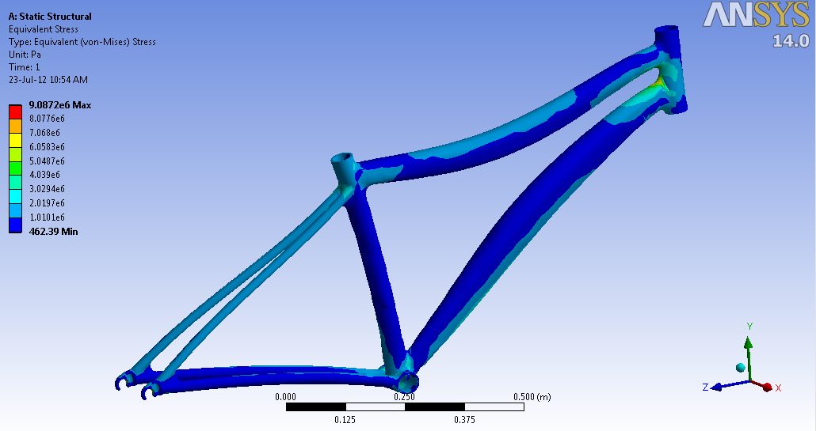

*Equivalent Von-mises stress*

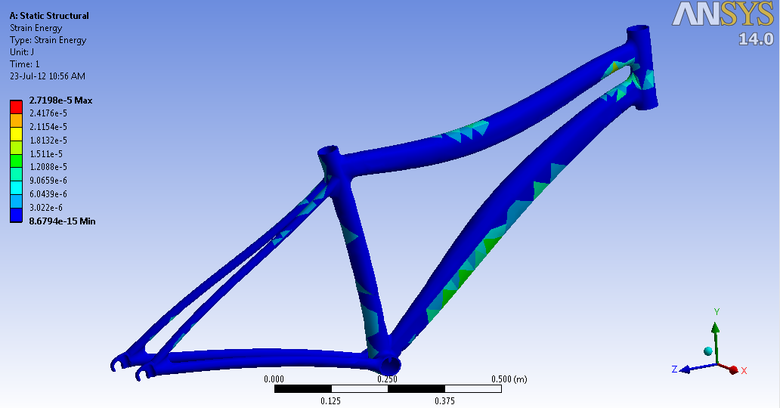

*Strain Energy* 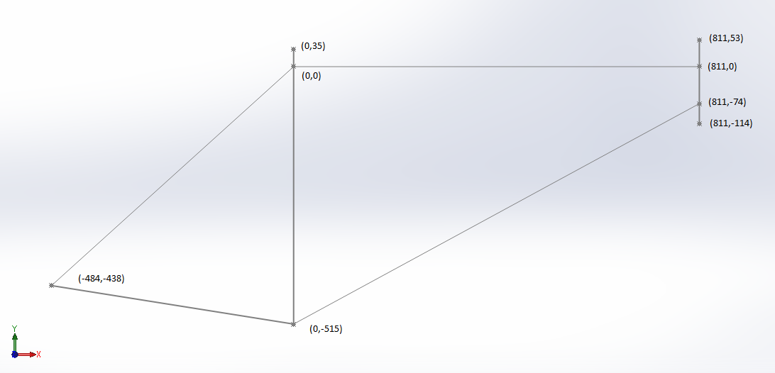

*Approximate model for Validation*

# Validation MATLAB Code

clc

clear all

close all

E=2*10^5;

Loc=[811 053

811 0

811 -74

Element Nodes

811 -114

0 35

0 0

0 -515

-484 -438];

[n,dump]=size(Loc);

El=[1 2 50 42

2 3 50 42

3 4 50 42

2 6 44 36

Frame Elements

5 6 48 40

6 7 48 40

3 7 44 36

6 8 20 12

7 8 20 12];

[r,c]=size(El);

K_global=zeros(3*n,3*n);

for(i=1:r)

L(i)=sqrt((Loc(El(i,1),1)-Loc(El(i,2),1))^2+(Loc(El(i,1),2)-Loc(El(i,2),2))^2);

A(i)=pi*(El(i,3)^2-El(i,4)^2)/4;

I(i)=pi*(El(i,3)^4-El(i,4)^4)/64;

Ang(i)=atan((Loc(El(i,2),2)-Loc(El(i,1),2))/(Loc(El(i,2),1)-Loc(El(i,1),1)));

end

for (i=1:r)

z=Stiffness_matrix( Ang(i),E,L(i),A(i),I(i) );

x=El(i,1);

y=El(i,2);

for(j=1:3*n)

for(k=1:3*n)

if(j==x*3-2 || j==x*3-1 || j==x*3) && (k==x*3-2 || k==x*3-1 || k==x*3)

K_global(j,k)= K_global(j,k)+z((j-(x-1)*3),(k-(x-1)*3));

elseif(j==y*3-2 || j==y*3-1 || j==y*3) && (k==y*3-2 || k==y*3-1 || k==y*3)

K_global(j,k)= K_global(j,k)+z((j-(y-1)*3),(k-(y-1)*3));

elseif(j==x*3-2 || j==x*3-1 || j==x*3) && (k==y*3-2 || k==y*3-1 || k==y*3)

K_global(j,k)= K_global(j,k)+z((j-(x-1)*3),(k-(y-1)*3));

elseif(j==y*3-2 || j==y*3-1 || j==y*3) && (k==x*3-2 || k==x*3-1 || k==x*3)

K_global(j,k)= K_global(j,k)+z((j-(y-1)*3),(k-(x-1)*3));

end

end

end

end

F_red=transpose([0 0 0 0 0 0 0 0 0 0 700 0 0 0 0 0 0 0]);

K_red=K_global;

K_red(10:12,:)=[];

K_red(:,10:12)=[];

K_red(19:21,:)=[];

K_red(:,19:21)=[];

Def=inv(K_red)*F_red

function [ K ] = Stiffness_matrix( Ang,E,L,A,I )

l=cos(Ang);

m=sin(Ang);

Ke=[ A*E/L 0 0 -A*E/L 0 0

0 12*E*I/(L^3) 6*E*I/(L^2) 0 -12*E*I/(L^3) 6*E*I/(L^2)

0 6*E*I/(L^2) 4*E*I/(L) 0 -6*E*I/(L^2) 2*E*I/(L)

-A*E/L 0 0 A*E/L 0 0

0 -12*E*I/(L^3) -6*E*I/(L^2) 0 12*E*I/(L^3) -6*E*I/(L^2)

0 6*E*I/(L^2) 2*E*I/(L) 0 -6*E*I/(L^2) 4*E*I/(L)];

[T]=[l m 0 0 0 0

-m l 0 0 0 0

0 0 1 0 0 0

0 0 0 l m 0

0 0 0 -m l 0

0 0 0 0 0 1];

K= transpose(T)*Ke*T;

end

# 

Axial effects with the shear force and bending moment effects, in

local coordinates

# Result Deformation Matrix

|  |  |  |  |  |  |  |  |  |
| --- | --- | --- | --- | --- | --- | --- | --- | --- |
|  | Element 1 | Element 2 | Element 3 | Element 4 | Element 5 | Element 6 | Element 7 | Element 8 |
| u (mm) | 0.0016 | 0.0016 | 0.0001 | N.A. | -0.0048 | 0.0048 | -0.0033 | N.A. |
| v (mm) | -0.0001 | 0.0001 | 0.0001 | N.A. | 0.0185 | -0.0183 | 0.0167 | N.A. |
| Theta(rad) | -0.0000 | 0.0000 | 0.0000 | N.A. | -0.0000 | 0.0000 | -0.0000 | N.A. |

